**Assignment 4 Report**

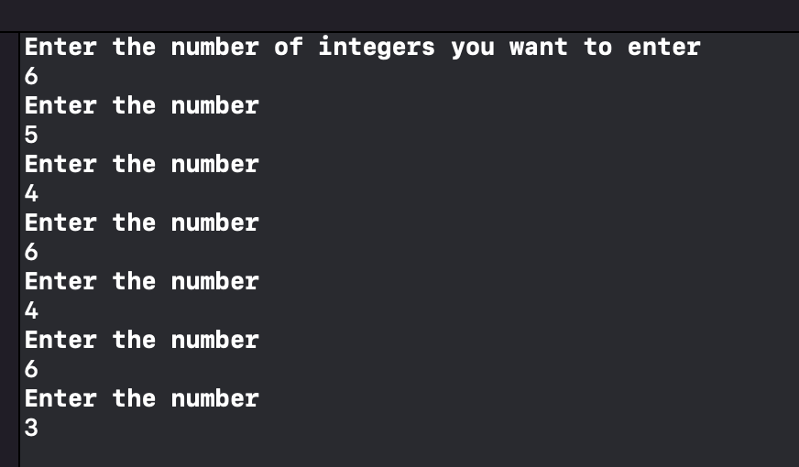

Here it is asking the user to enter the number of elements entered in the vector and then the user enters the values of the number of the vector.

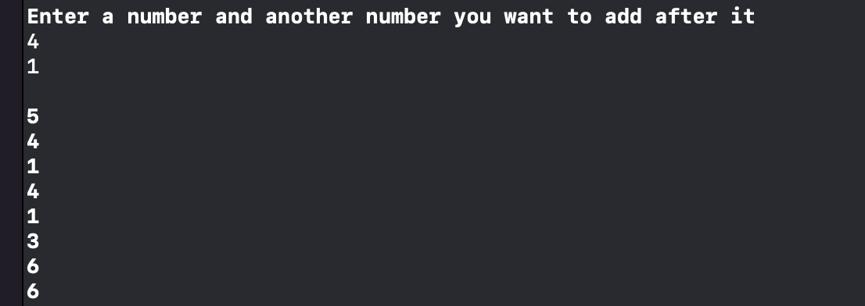

Asks the user to enter the number they want to find and also enter the number they want to insert after each occurrence the second number.

And here is the display of the vector after a value is inserted after each number.

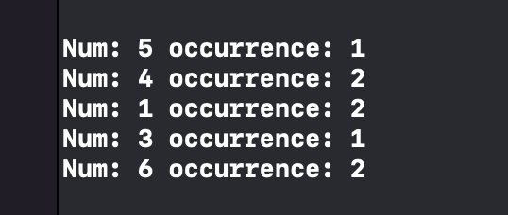

This is the output of the linked list looks like after it was created.

In the function it shows each number in the linked list and the number of times it occurred in the vector.

For this to be created each element in the vector has to be compared to all the other elements in the vector then if it is found a count variable is incremented to count all the times each number has occurred in the vector and the number and its

occurrences are recorded inside the linked list then it is printed.

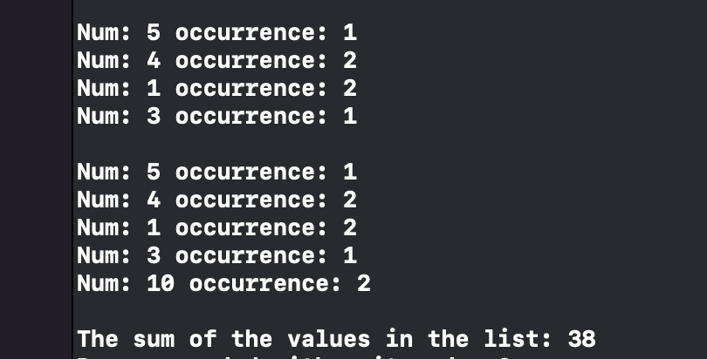

The last element in the linked list is removed here

And then 10 of occurrence 2 is added to the end of the linked list

Then the sum of all the elements with the occurrences is calculated and printed here it is done by multiplying each number and their occurrence.